**Initial Mockup - Blood Bank**

Team Members : Hari Krishnan Raj Kumar, Lakshmi KS, Nidhi Kumar, Shristi Shrivastava

**Data flow:**

This below diagram explains how the user accesses all the functionalities and how the User interacts with.

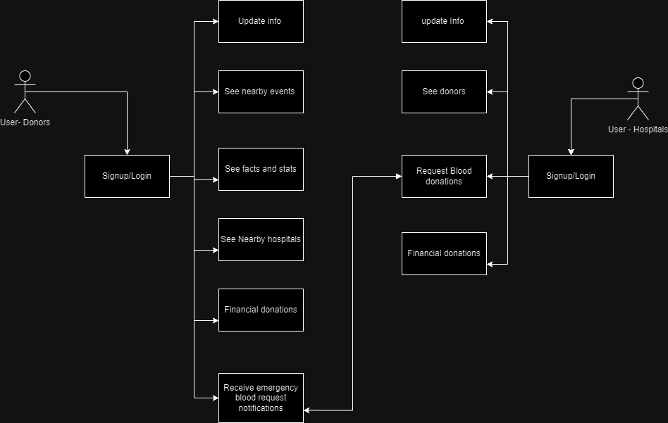

**UI Mockup:**

The below are the UI Mockups for User - Initial screen, signup and login

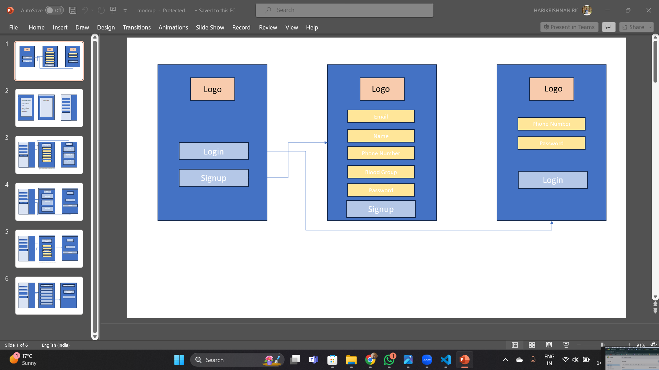

The below is the user - donor’s homepage, clicking on the event will open an event screen. The third image is the navigation drawer. It will show the active donation requests for the logged in user’s Blood group.

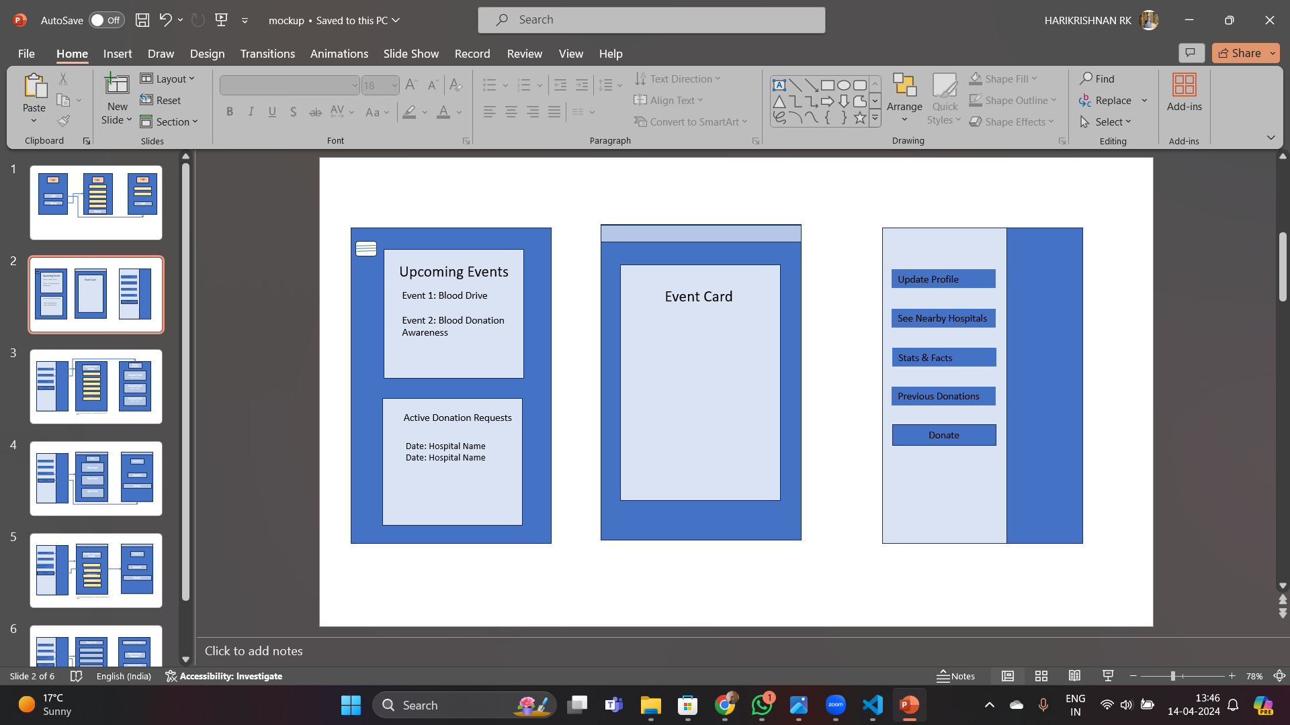

The below screens show the users ability to update their profile and see nearby hospitals

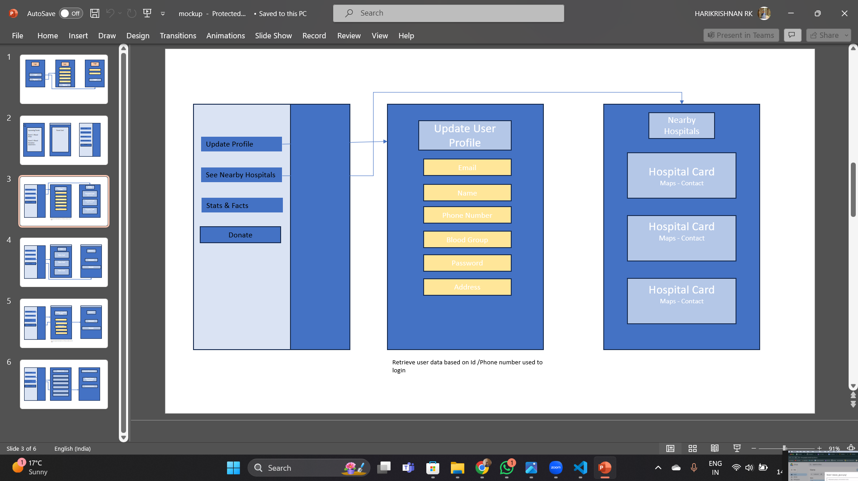

The below UI Mockups show the user’s ability to see stats and facts and also to use the donate function for financial donations.

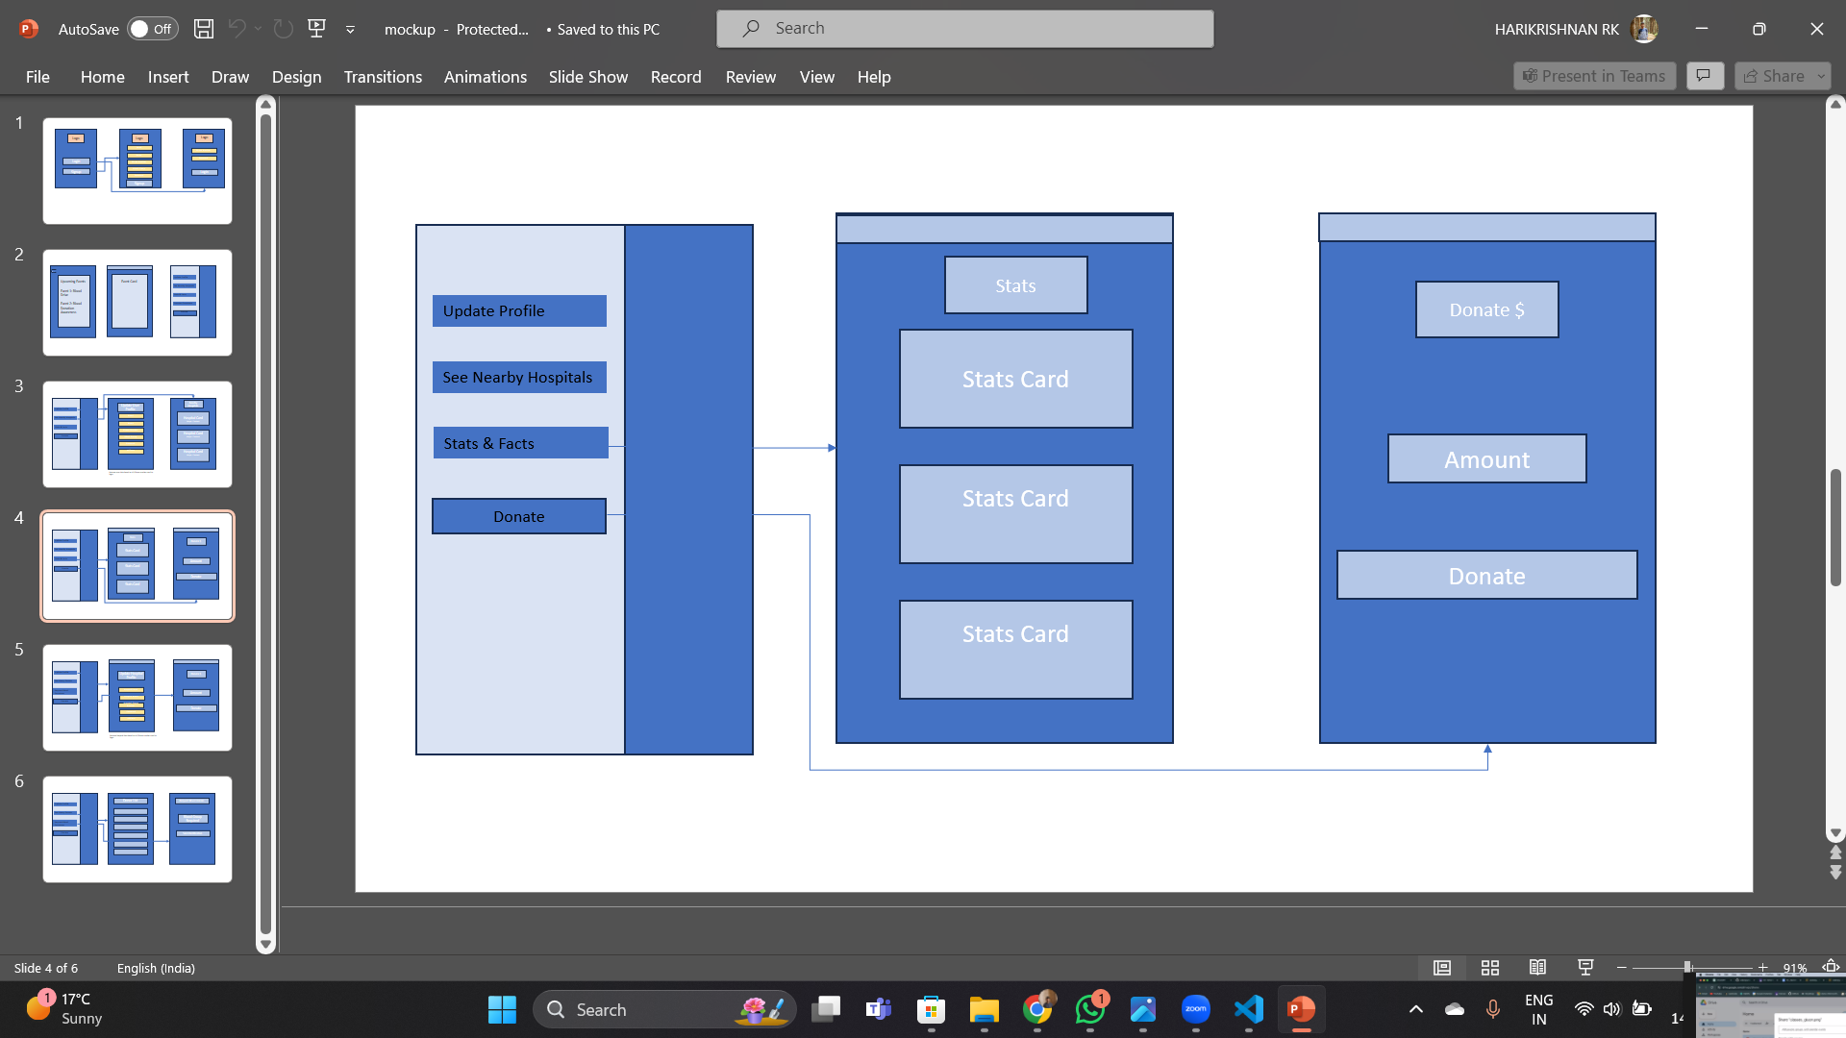

The below UI mockup’s show the navigation drawer updation of hospitals profile and financial donations options for hospitals. This is for the Hospitals User.

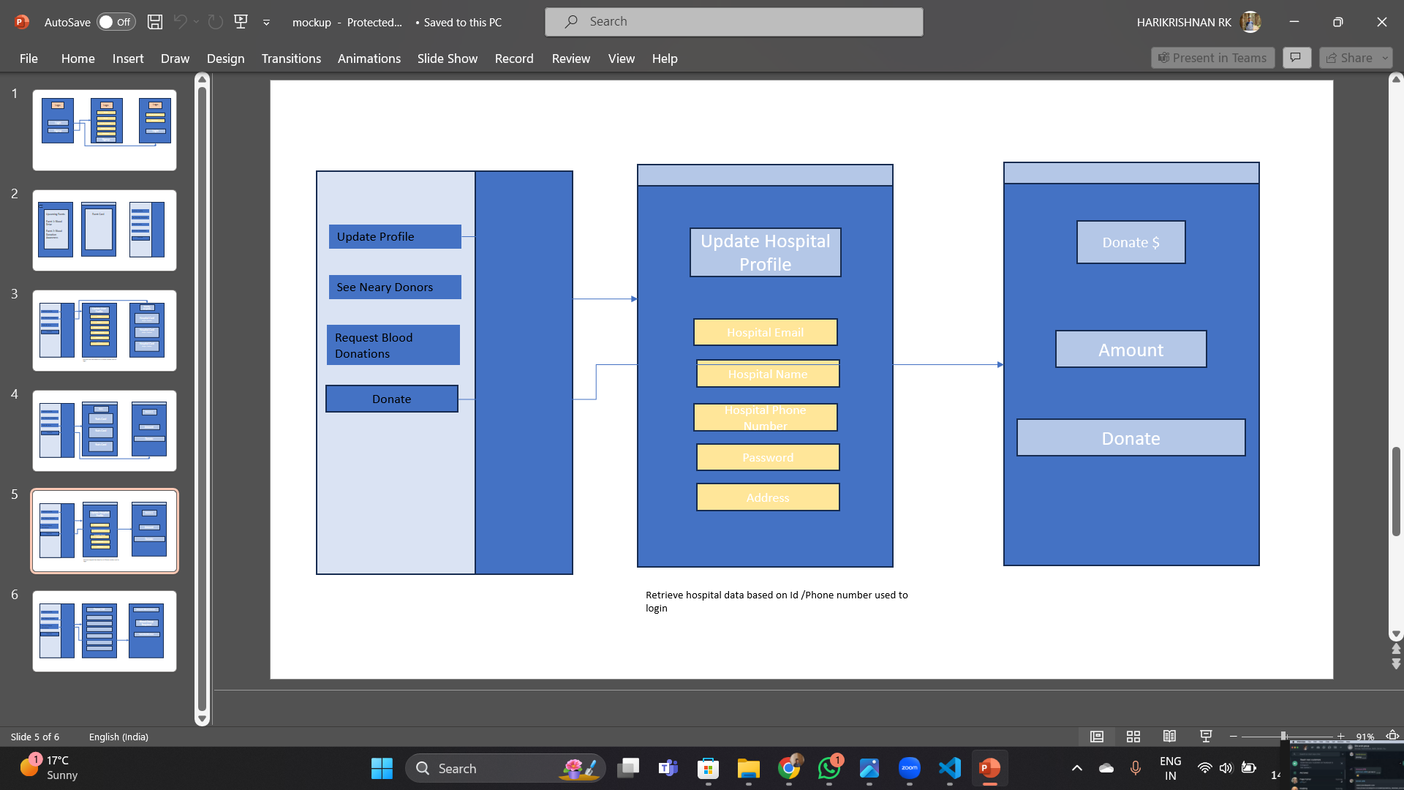

The below is Functionality for User- Hospitals to see donor lists and request donations, the filter option will allow to filter by blood groups and distances to send notifications to donors in bulk. As of now we are planning to use email notifications in order to avoid expenses for cloud services which are needed for push notifications.

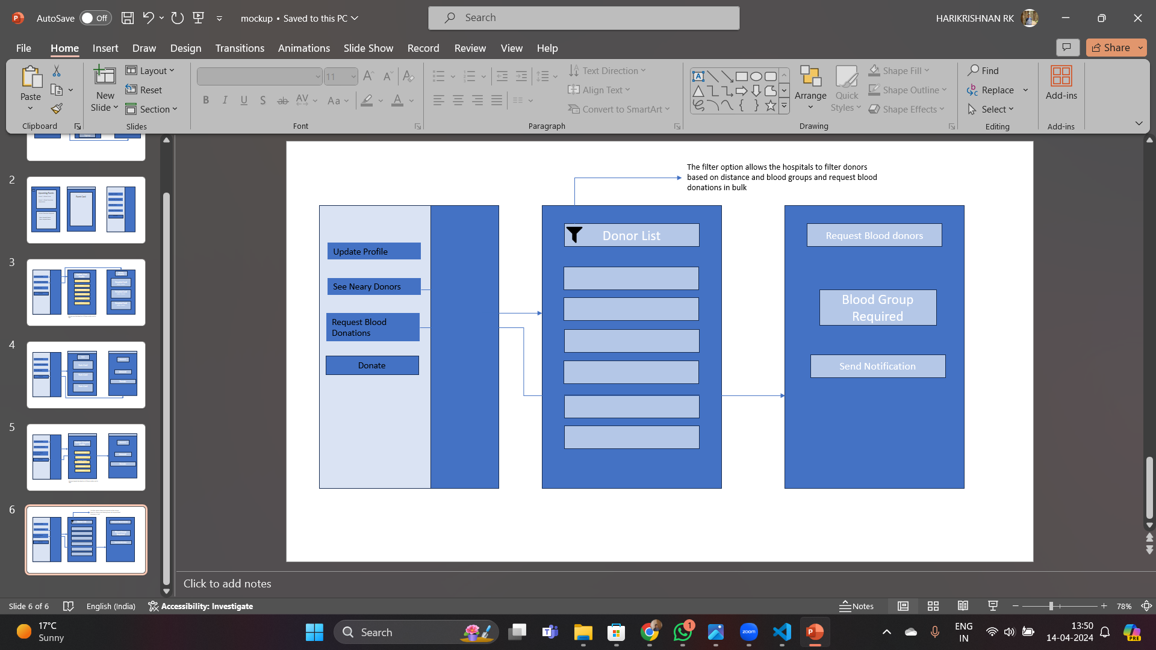

**Brief description on how the design is relevant to the target demographic:**

**General Public:**

* The UI is mockups designed for the intro screen, signup and login are user-friendly, which as a result makes the application accessible from any age group, or tech proficiency level.
* The homepage and event screens of the donors are user friendly and interactive, and therefore, attracts people who donate blood regularly and those who just make occasional contributions during an emergency.
* Offers like profiling of health providers, streaming nearest health centers and delivering of statistics and facts uplift the clients' experience, closely relating to the self-conscious and information-seeking health seekers who appreciate ease.
* The donate function financial contribution additionally serves as a means of support by catching the eye of non-donors who want to also participate but may not be able to donate blood but donate in terms of money to the cause.

**Hospitals and Healthcare Facilities:**

* The app has become a vital tool for community-based hospitals during emergency situations and makes it easy to call upon the ready-force donor unit. The functional features which allow one to schedule blood donations by providing references to filter blood groups and distances ease the process hence streamlining donor management for efficiency.
* The fact that the hospitals have such privileges like access to donors' top lists and prompt information help them cope with the problem on time, maintaining high quality of medical care.

**Community Organizations and NGOs:**

* Organizations such as blood banks and projects can use the app to run campaigns asking for donations and making appointments with the help of the app. As a result of these activities, people will stay engaged with the community and together will come up with further support for the needed initiatives.

**Happy Path:**

Here's a breakdown of our defined happy path

**1. Initial User Interaction:**

* User gets to the home screen and is given the choice of either signup or login in a clean and organized manner.
* They choose the appropriate action as required

**2. User Registration/Login:**

* New users are not left behind as they enter the registration process with ease, prompted to enter the necessary details and thereby verifying their email address.
* Returning users log in with their credentials quickly and securely.

**3. Exploring Donor's Homepage:**

* At the time of log in, users find themselves on the donor's homepage, where they can see the upcoming activities and access relevant information.
* They click on an event to view details or proceed to explore other functionalities.

**4. Updating Profile and Exploring Nearby Hospitals:**

* Users will navigate their profile settings and will be able to edit information as required making correctness and completeness intact and full.
* They explore nearby hospitals using the provided feature, which displays relevant information and directions by opening maps when needed

**5. Accessing Stats and Facts and Making Donations:**

* Users of the app are able to use the various features to find the ultimate behavior involved in blood donation and thus, expand their knowledge and make them aware.
* Some users choose to make financial donations, contributing to the cause even if they are unable to donate blood themselves.

**6. Hospital User Functionality:**

* A patient user on this app accesses their account and goes to specific features in which they are focusing like updating their hospital profiles and donations.
* They may also view donor lists, request blood donations, and utilize filters to streamline the process.

**7. Community Organization Engagement:**

* Community organizations and NGOs leverage the app to launch campaigns, seek donations, and organize donation drives.
* They utilize the platform's features to engage with donors and facilitate support for their initiatives.

**8. Notifications through emails:**

* Donors get critical notifications through emails and push notifications in the app.

Throughout this defined happy path, users encounter intuitive interfaces, clear navigation paths, and seamless interactions, enabling a positive user experience and successful achievement of their objectives related to blood donation and support.

## **Success Criteria**

**1. User Adoption and Engagement:**

- Registration Rate: Through achieving the registration ratio of 80% among the population eligible for the blood donation, the general contribution to the blood system would be high enough.

- Active User Engagement: The effort to increase the user retention rate of the application shows the users active engagement with the application in not less than 60% of the total registered user monthly.

**2. Blood Donation Impact:**

- Donation Volume: The application is envisioned as a tool for seeing that 40% of the blood donations facilitated through the application, compared to the baseline, meet the blood supply demands as desired.

- Emergency Response Time: The application’s utility is evident in prompting responses to emergency blood donation requests with a response time of less than 30 minutes.

**3. Hospital Adoption and Satisfaction:**

- Hospital Registration Rate: Ensuring at least 70% of the hospitals who are eligible bind partnerships allows wide outreach, encouragement and usage of the app for their blood donation management and coordination.

- Satisfaction Surveys: Collect feedback and suggestions and evaluate satisfaction

**4. Community Impact and Recognition:**

- Lives Saved: Recording and safeguarding the quantitative and qualitative data of the life-saving effect of having the blood donations on schedule due to the application will give undeniable evidence of the lives saved or positively impacted.

- Community Recognition: Achieving positive media coverage, testimonials and procurement of recognition awards from healthcare institutions and community leaders is sufficient proof of the application's significance in solving the blood donation problems and saving lives.

**Design aligns with success criteria**

Here's how our design aligns with each criterion:

**1. User Adoption and Engagement:**

* Registration Rate: Through an easy to use interface and simple operation features, we intend to obtain 80 % registration of eligible donors, and thus involving as many people as possible.
* Active User Engagement: By offering seamless navigation and valuable functionalities, we strive to maintain a 60% monthly user retention rate, indicating sustained engagement with the application.

**2. Blood Donation Impact:**

* Donation Volume: Through the features like event notifications, news on the hospital and donation options, our application will try at least 40% of the blood donations. In this way, it will meet the demands completely.
* Emergency Response Time: The app's unique feature that utilizes prompt response mechanisms aims at a turn around within the next 30 minutes for emergency blood donation requests done to ensure timely assistance during the critical times.

**3. Hospital Adoption and Satisfaction:**

* Hospital Registration Rate: We offer a few tailored features for the hospitals and one of them is regarding the donors, the lists of donor lists and the donation request options which intend to get partnerships with at least 70% of eligible hospitals and thus streamline the blood donation management. The filter option to request blood groups could be an impactful feature to motivate hospitals to register
* Satisfaction Surveys: The incorporation of feedback mechanisms serves for the purpose of gathering hospital satisfaction data, after which a continuous improvement is performed through this data and ensures the enjoyment of our institutional partners at a high level.

**4. Community Impact and Recognition:**

* Lives Saved: Comprehensive data storage is the approach to be used in order to illustrate real values by reflecting on blood donations that are effectively saved through the platform.
* Community Recognition: Positive media coverage, testimonials, and recognition awards serve as testimony to the app's significance in addressing blood donation challenges and contributing to community welfare.